**Project Report Template**

**RETAIL MANAGEMENT USING SALESFORCE APPLICATION**

1. **Introduction:**
   1. Overview

A CRM product owner has requested to create two applications, one is a sales app for sales reps to use this application and store customers data, and the second application is a service app for service reps/agents to provide support to customers in dealing cases. To generate business on top of the customers.

* 1. Purpose

Retail management optimizes internal process such as inventory management, offline storefronts, warehouse operations, payment and accounting, and human resources.

1. **Problem Definition & Design Thinking**
   1. Empathy Map

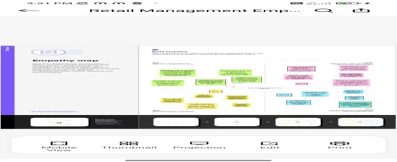

* 1. Ideation and Brainstorming Map

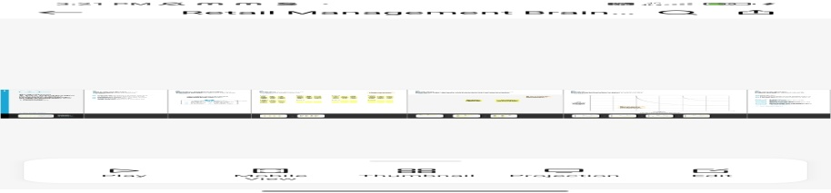

1. **Result**

**3.1** Data Model

|  |  |  |
| --- | --- | --- |
| **Object Name** | **Field Label** | **Data Type** |
| Account | Account Name | Lookup |

**3.2** Activity & Screenshot

We done empathy map and brain storming and uploaded in Github. Alos we done the trailhead badges completion and earn points.

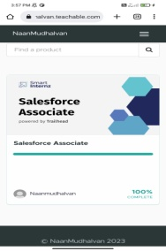 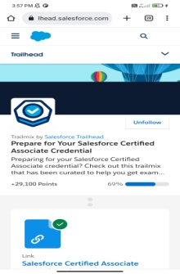 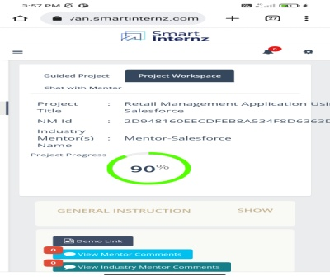

1. **Trailhead Profile Public URL**

Team Leadhttps://trailblazer.me/id/susat3

Team Member 1https://trailblazer.me/id/urajan2

Team Member 2https://trailblazer.me/id/vaiag

Team Member 3https://trailblazer.me/id/vdurga43

Team Member 4https://trailblazer.me/id/yamunarani03

1. **Advantages & Disadvantages**

Advantages

* Require less capital
* More Profit Margin than wholesalers
* Better customer relation
* Credit facility
* No Liability towards the buyers

Disadvantages

* Requires more marketing costs
* Good selling skills is required
* High competition
* No benefit of bulk buying

1. **Applications**

* Improved Customer relationship management
* Better collaboration and communication between teams
* Reduce IT costs

1. **Conclusion**

Salesforce can be used to manage orders from retail stores and distributions, including tracking orders, processing payments, and managing inventory levels.

1. **Future Scope**

Supervisiory, client communications, merchandise shipment, sales, management and administrative services all are future scopes of retail management.